______________________________________________________________________________
The Effect of the iPhone Text Tone upon Short Term Memory
Author(s): Casey Feinstein and Autumn Johnson
Submitted: January 15th, 2016
______________________________________________________________________________

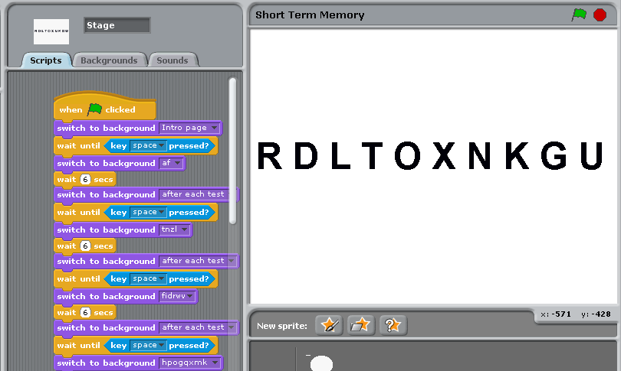

Abstract:
Short term memory (STM) is the conscious, brief retention of information that is currently being processed in a person’s mind”, (McGraw-Hill 2003). Auditory distractions have been found to negatively affect short term memory abilities of all humans (Yung Kyun 2013). Our study investigates whether the default text tone of an iPhone would affect someone’s short memory abilities. 30 students and teachers at Roland Park Country School were tested for the impact of the iPhone notification tone on STM using a computer program called SCRATCH made by MIT students. It was concluded that when the subjects were shown 2 and 4 letter tests (p=1.0), an 8 letter test (p=0.07), and a 10 letters test (p=0.74), their ability to remember was not significantly affected by the distractor. But, when shown 6 letters, the distractor decreased STM recall in a very statistically significant way (p=0.008).

Introduction
Short term memory (STM) is “the conscious, brief retention of information that is currently being processed in a person’s mind”, (McGraw-Hill 2003), and it plays a critical role in the brain’s ability to store, process, and access memory of any kind. Therefore, anything that might influence STM has the potential to impact and even disrupt the entire memory processing system. Studies have already shown that distraction conditions, such as making someone count out loud, decrease both older and younger children’s ability to recall information equally (Itagen, 1973). Furthermore, while older people, such as college students, perform better under distracting conditions than younger people do (probably because their minds are more developed and trained to disregard distractions in a testing situation [Trentham 1975]), all individuals have their STM impaired more when the distractions are auditory rather than visual (Yung Kyun 2013).
However, with the advent of the smartphone, society now has a more regular and consistent potential source of auditory distractions along with a generation of individuals who have potentially learned to ignore it. Therefore, this study tests the effect that the default text tone of an iPhone has on one’s ability to remember different sequences of random letters in order and to see how distractions from one possible phone notification might impact STM. We hypothesized that adding the distractor (the default iPhone notification) when presented different sequences of random letters would make the subject perform worse on a memory recall test than they would do under the non-distracted condition.

Methods
30 students and teachers at Roland Park Country School were tested for the impact of the iPhone notification tone on STM using a computer program called SCRATCH created using MIT’s software. Test subjects were first shown a screen with a set of instructions informing them how to complete the STM recall tasks, and then once each subject pressed the spacebar key initiating the test, each subject was shown a screen with 2 random letters for 6 seconds. Following the 6 seconds, each subject was asked to record all the letters they could recall. Next, each subject was shown a screen with 4 random letters for 6 seconds. Following the 6 seconds, each subject was asked to record all the letters they could recall. Next, each subject was shown a screen with 6 random letters for 6 seconds. Following the 6 seconds, each subject was asked to record all the letters they could recall. Next, each subject was shown a screen with 8 random letters for 6 seconds (for example see figure 1). Following the 6 seconds, each subject was asked to record all the letters they could recall. Next, each subject was shown a screen with 10 random letters for 6 seconds. Following the 6 seconds, each subject was asked to record all the letters they could recall. Headphones were worn throughout to control for sound.
Once the first 5 screens of random letters were displayed, each subject was asked to repeat the same test with the distractor, using new sequence of random letters. Test subjects were not informed of the distractor. During the tests, the distractor occurred by having 3 iPhone text notification sounds go off during each test. The sounds started at the beginning of each test screen and went off every other 1 second.

Figure 1
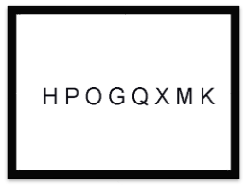
Results:
Graph 1
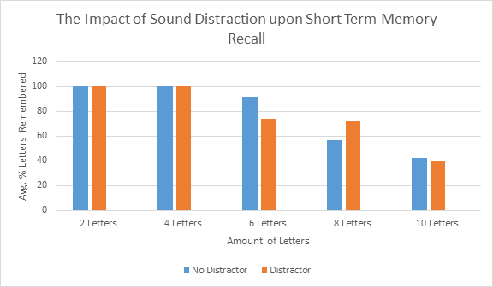

Table 1: The Results of a t-Test Comparison between the Distractor and the Negative Control
Amount of letters presented to test subjects | p - Value
2 Letters | 1
4 Letters | 1
6 Letters | 0.008
8 Letters | 0.07
10 Letters | 0.74

Discussion:
As graph 1 shows, there is limited support for our hypothesis. While the presence of the distractor failed to have any statistically significant impact from the distractor when the subjects were shown 2 letters (p=1.0), 4 letters (p=1.0), 8 letters (p=0.07) or 10 letters (p=0.74), the distractor did decrease STM recall in a statistically significant way when the subjects were shown 6 letters (p=0.008).
Furthermore, while the distractor did not appear to have any meaningful impact when subjects were shown 8 letters and then 10 letters to recall, The percent of letters remembered still went down at a constant rate as the number of letters increased, widely confirming the documented fact that as the amount a human is given to remember increases, the amount that they remember is lowered (Morgan 1917).
For future work, we could try different “tone” distractors of an iPhone, including the default email sound or a Snapchat notification sound, and see how it compares with the text tone that we used in this experiment to see which might be more distracting. We could also change the volume of the distractor to test at which point it becomes too loud to focus. Another thing we could look further into is what was happening at the 6 letter stage. Testing more people than we did in the initial test could show us if the data we collected for this was just specific to the group we tested, or if it is something that can happen with all humans.

Bibliography & Acknowledgements:

Call, M. E., (1985) Auditory Short-term Memory. Teachers of English to Speakers of Other Languages, Inc. 19, 765 – 781. http://ww.jstor.org/stable/3586675

Choi, Y.K., Lee, S.M., & Li, H. (2013). Audio and Visual Distractions and Implied Brand Memory: A Study of Video Game Players. Journal of Advertising, 42./3, 219-227. http://search.proquest.com/docview/1448810197/6DFAB9AB27F04609PQ/1?accountid=297

Gabriel, D., Gaudrain, E., Lebrun-Guillaud, G., Sheppard, F., Tomescu. I. M., & Schnider, A. (2012) Do Irrelevant sounds impair the maintenance of all characteristics of speech in memory. J Psycholinguist Res. 41, 475 – 486. https://www.researchgate.net/publication/221697409_Do_Irrelevant_Sounds_Impair_the_Maintenance_of_All_Characteristics_of_Speech_in_Memory

Hagen, J. W., & Kail, R. V.. (1973). Facilitation and Distraction in Short-Term Memory. Child Development, 44(4), 831–836. http://doi.org/10.2307/1127733

John J. B. Morgan. (1917). The Effect of Sound Distraction upon Memory. The American Journal of Psychology, 28(2), 191–208. http://doi.org/10.2307/1413720

Klatte, M., Lachmann, T., Schlittmeier, S., & Hellbrück, J., (2010) The Irrelevant sound effect in short term memory: Is there development change?. European Journal of cognitive Psychology. 22186, 1168 – 1191. https://www.sowi.uni-kl.de/fileadmin/frueh/publications/klatte_lachmann_etal_ise_ejcp_2010.pdf

Trentham, L. L.. (1975). The Effect of Distractions on Sixth-Grade Students in a Testing Situation. Journal of Educational Measurement, 12(1), 13–17.http://www.jstor.org/stable/1434370

---

We would like to thank our respective STEM teachers, Mr. Brock and Ms. Booker, for their unconditional insight and feedback to us throughout this study. We would also like to thank our test subjects for lending their time to help us carry out this experiment.

